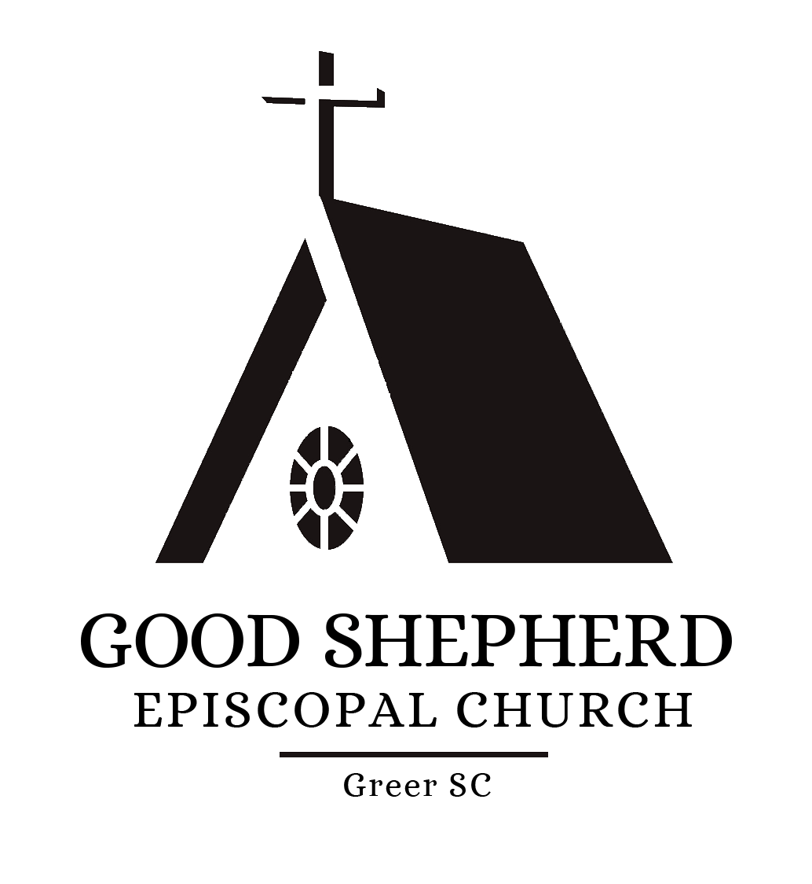

Church of the Good Shepherd

Wedding Policies and Guide

Congratulations and best wishes on your wedding. We want to help make your wedding at the Church of the Good Shepherd a blessing to you and all who participate in helping you celebrate. In that regard, please read carefully the information contained in this packet. In addition to the “rules and regulations” regarding the use of our Church and other spaces, you will find guidance in marking the beginning of your marriage with beauty and ease.

Good Shepherd is a beautiful space that seats approximately 100 people. A center aisle is the perfect setting for your momentous “walk down the aisle”. Several rooms are also available to you as a special gathering space for your wedding party to dress and prepare for your event.

You may book your wedding in our Church up to 18 months in advance of your wedding date, with all fees remaining at the quoted rates. We hope that the following information will guide you through your wedding plans. You will find a convenient checklist at the end of this packet for your use as you complete each step of the planning process. If you still have questions after reading through these materials, feel free to call the Church office.

Holy Matrimony in the Episcopal Church

Holy Matrimony is one of the seven sacraments of the Episcopal Church. It is regarded as an outward and visible sign of an inward and spiritual grace, given by Christ as a sure and certain means by which we receive that grace. Therefore, any marriage taking place at The Episcopal Church of the Good Shepherd is never to be regarded as merely a civil ceremony, but as a solemn and sacred liturgy of the Church. As stated in the wedding liturgy from THE BOOK OF COMMON PRAYER:
The bond and covenant of marriage was established by God in creation, and our Lord Jesus Christ adorned this manner of life by His presence and first miracle at a wedding in Cana of Galilee. It signifies to us the mystery of the union between Christ and his Church and Holy Scripture commends it to be honored among all people. The union of husband and wife in heart, body, and mind is intended by God for their mutual joy; for the help and comfort given one another in prosperity and adversity; and, when it is God's will, for the procreation of children and their nurture in the knowledge and love of the Lord. Therefore, marriage is not to be entered into unadvisedly or lightly, but reverently, deliberately, and in accordance with the purposes for which it was instituted by God.
(THE BOOK OF COMMON PRAYER, page 423)

All marriages to be solemnized at The Episcopal Church of the Good Shepherd must conform not only to the laws of the State of South Carolina (having a valid license to be married) but also to the rubrics of THE BOOK OF COMMON PRAYER along with the canon laws of the Episcopal Church USA. The rector of the parish shall have full responsibility and be the final authority for the interpretation and/or application of any and all wedding policies, customs, and guidelines for The Episcopal Church of the Good Shepherd.

If either party seeking Holy Matrimony in this Church has had a prior marriage annulled or dissolved by a civil court, then at least one of the parties seeking Holy Matrimony must be a member in good standing of the Episcopal Church as defined by canon law.

Such a marriage requires the rector to consult with and obtain the permission of the Bishop of Upper South Carolina for the solemnization. No date for the solemnization of the marriage shall be set until the consent of the Bishop has been received (this process typically requires approximately sixty to ninety days).

If either party of a proposed marriage has had more than one previous marriage annulled or dissolved by a civil court, premarital counseling with a licensed marriage counselor or family therapist (approved by the rector) will also be required prior to requesting the Bishop's consent to the solemnization of the marriage. This is in addition to the required premarital meetings with the rector.

It shall be within the discretion of the Rector of this Church to decline to solemnize or bless any marriage, in accordance with the Canons of The Episcopal Church.
Holy Matrimony at The Church of the Good Shepherd

- The Church of the Good Shepherd affirms the sacramental nature of marriage for all people.

- To have your wedding at the Church of the Good Shepherd, you must have the permission of the Rector of the Church. It is preferable that the Rector of this Church perform the ceremony.

- At least one of the wedding partners must be a current member in good standing at Good Shepherd or a family member of such. The Rector may make exceptions.

- A member in good standing is recorded in the parish register as a baptized or confirmed member, is known to the clergy as regular in corporate worship and is known to the parish treasurer as a regular financial contributor.

- The Constitution and Canons of the Episcopal Church Title I, Canon 18: Of the Celebration and Blessing of Marriage, governs the administration of the Sacrament of Holy Matrimony at Good Shepherd.

- The Book of Common Prayer provides the form for all weddings in the Episcopal Church.

- Canonically, premarital counseling must take place. The Rector has the responsibility to either do the counseling or make arrangements for an acceptable alternative. The Rector of Good Shepherd will set the number of counseling sessions required.

- Good Shepherd’s Wedding Committee and others as necessary will provide all logistical support for any wedding held on our premises. Wedding planners chosen by the wedding partners, if applicable, may assist the Wedding Committee, but will have no control over the conduct of the marriage ceremony.

- There is to be NO FLASH PHOTOGRAPHY during the wedding ceremony.

- Due to demands on the Church staff and volunteers, wedding ceremonies must be complete by 10:00 pm, with cleanup complete by 11:00 pm.

- Wedding bulletins are the responsibility of the wedding party.

- Receptions are the responsibility of the wedding party and may be held in Ballenger Hall (see charges below).

CHARGES:

- Church Cleaning Fee $150

- Organist $250

- Ballenger Hall Cleaning Fee $250

Wedding Policies for the Florist

The Church of the Good Shepherd has developed the following guidelines to avoid damage to its property and furnishings and to also inform regarding our expectations in upholding the sanctity of our worship space. Please review them carefully. If you wish to see the Church prior to the wedding date, you may contact the Church office at (864) 877-2330 during office hours.

- Flowers may be arranged by a chosen florist. Flowers shall not overwhelm the ceremony. It is customary to leave the flowers in the Church as a thank offering.

- Seasonal decorations (Easter lilies, Christmas tree, Advent wreath, etc). that are in place on the day of the wedding will remain in place. Please do not ask that they be removed.

- No nails, tacks, or staples may be used to attach any decorations to Church property.

- If pew markers are used, pews must be protected against scratching and/or gouging by clamps.

- Only white aisle runners are permitted. Flower petals or other live/organic materials are not allowed to be spread on the church floor. Artificial flowers are permitted.

- All decorations and equipment must be removed IMMEDIATELY after the ceremony. The Church cannot be responsible for moving and/or storing any equipment.

- The Church will be open 4 hours prior to the wedding. Delivery and set-up must be within this time frame.

Signature of Florist

_______________________________________________________________________

Signature of Bride/Groom

_______________________________________________________________________

Wedding Policies for the Photographer/Videographer

The Church of the Good Shepherd has developed the following guidelines to avoid damage to its property and furnishings and to also inform regarding our expectations in upholding the sanctity of our worship space. Please review them carefully. If you wish to see the Church prior to the wedding date, you may contact the Church office at (864) 877-2330 during office hours.

- We require that there be NO flash photography or other lighting during the wedding ceremony; however, it is allowed before and after. Only cameras with a silent shutter may be used during the ceremony. This applies to wedding attendees, as well.

- Videography during the ceremony may be taken from the back of the Church only and must not obstruct the flow of the service. The location of the photographer/videographer must be approved by the priest prior to the ceremony.

- All pictures taken in the Church are to be done BEFORE leaving to take any outside pictures, since the Church will need to be cleaned as soon as possible after the ceremony concludes. Photography should not extend beyond 30 minutes after the ceremony.

- We consider the altar to be a sacred space. Therefore, it will only be permissible for the wedding party to assemble outside the altar railing. Only the Priest and Eucharistic Ministers are allowed inside the altar railing.

- Seasonal decorations (Easter lilies, Christmas tree, Advent wreath, etc). that are in place on the day of the wedding will remain in place. Please do not ask that they be removed.

- Nothing must be added to or taken away from the altar table. Due to the sanctity of the altar table, it can only be used for traditional elements of worship. The candles must remain on the altar table. The altar table may not be moved from its location.

- All decorations and equipment must be removed IMMEDIATELY after the ceremony. The Church cannot be responsible for moving and/or storing any equipment.

- The Church will be open 4 hours prior to the wedding. Set-up must be within this time frame.

Signature of Photographer/Videographer
_______________________________________________________________________

Signature of Bride/Groom
_______________________________________________________________________

Wedding Information Sheet

/
Applicant’s Last Name Applicant’s Last Name

_______________________________/______________________________________
Church of the Good Shepherd Member Relation of Applicants to Member

Rehearsal Date Time ___________________

Wedding Date Time

B r i d e / G r o o m’ s N a m e

Address

Phone

Email Home Church _______________________

G r o o m / B r I d e ’s N a m e

Address

Phone

Email Home Church _____________________

Name and Church affiliation of Priest performing wedding ________________________________________________________________________

Name of Organist (It is expected that the Church’s organist will play for the ceremony. Exceptions may approved by the Rector.)

Total Number of Attendants: How many are children? ____

Florist Name Phone________________

Photographer Name Phone ________________

If you are not living in the Greer, SC area, please provide the name and number of a local contact person below:

Name Phone
Wedding Party

List of Attendants and any Special Designation (e.g. Bridesmaid, Best Man, etc.):

______________________________________________________________________

______________________________________________________________________

______________________________________________________________________

______________________________________________________________________

______________________________________________________________________

______________________________________________________________________

______________________________________________________________________

______________________________________________________________________

______________________________________________________________________

______________________________________________________________________

______________________________________________________________________

______________________________________________________________________

______________________________________________________________________

______________________________________________________________________

______________________________________________________________________

Certificate of Intent for Holy Matrimony

We understand the teaching of the church that God's purpose for our marriage is for our mutual joy, for the help and comfort we will give to each other in prosperity and adversity, and, when it is God's will, for the gift and heritage of children and their nurture in the knowledge and love of God.
We also understand that our marriage is to be unconditional, mutual, exclusive, faithful, and lifelong; and we engage to make the utmost effort to accept these gifts and fulfill these duties, with the help of God and the support of our community.

Signature of Bride/Groom

Signature of Bride/Groom

Signature of Clergy

Wedding Checklist

(Please use this as your working copy to keep up with deadlines and planning)

Call or email the Church Administrator to check the availability of the facilities for the date you desire.

Complete the Wedding Information Sheet that is in this packet and return it to the Church office as soon as possible.

Name of Florist and Florist Signature advising of flower policies.

Name of Photographer and Photographer advised of photography policies.

_________Obtain SC marriage license two weeks prior to ceremony

Any fees paid to Church office 30 days prior to rehearsal.

Meet with Wedding Committee and decide on: Number of Dressing areas needed:
Time needed to come to the Church on day of wedding:

The Wedding Committee is representative of the Church to help with questions regarding policies of the Church of the Good Shepherd. The Wedding Committee can assist you with understanding rules about use of the altar area, floral arrangements and photography policies.

The Wedding Committee will also manage your wedding during the event. That includes making sure all people in the wedding party are dressed and in their appropriate place and cuing the ushers as to how to seat the family members, sending the wedding party down the aisle in the appropriate order.

Thank you and Congratulations!

