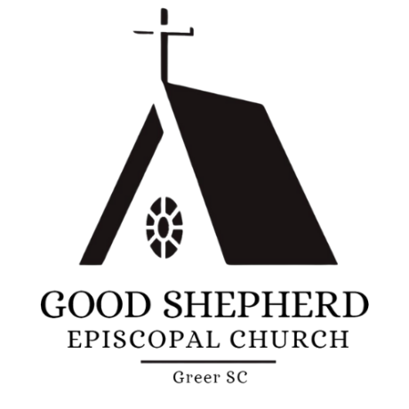

Purpose
This sets forth the Church of the Good Shepherd’s policy for use of facilities owned and controlled by the Episcopal Church of the Good Shepherd (the Church).

General
- The Rector of the Church of the Good Shepherd is entitled to the use and control of the Church and Parish buildings together with all appurtenances and furniture, in accordance with the Canons of The Episcopal Church. As such, the Rector is the final authority concerning the use of Church facilities.
- Use of Church facilities shall be in accordance with any Vision Statement adopted for The Church of the Good Shepherd.
- Use of Church facilities for Good Shepherd religious activities shall have priority over other uses. Scheduling conflicts will be resolved by the Rector in the best interest of the Church.
- Use of Church of the Good Shepherd facilities shall be in accordance with the Canons of The Episcopal Church and the Episcopal Diocese of Upper South Carolina.
- It is recognized that the initial request for the use of Church facilities will likely come from personal contact, such as email, phone call, messaging, etc. Availability of the facilities requested should be determined before continuing with the Facility Use process.

Church of the Good Shepherd Groups
- Church of the Good Shepherd Groups are defined as any group or organization reasonably considered a part of the Church of the Good Shepherd and that support the mission or vision of the Church. Examples are The Daughters of the King, the Men’s Group, The Good Shepherds, and the Vestry.
- Good Shepherd groups may request use of Church facilities through the Parish Clerk or directly through the Rector or Senior Warden, as appropriate.
- Use of the Facility Use Request Form is not required.
- Once approved, the Group is responsible for notifying the Parish Clerk of the event and date/times, if appropriate.

Church of the Good Shepherd Individuals
- Good Shepherd individuals are defined as members of the Church as listed on the rolls of the Church, as well as Active Participants of the Church, as determined by the Rector.
- Good Shepherd Individuals may request use of Church facilities through the Parish Clerk or directly through the Rector or Senior Warden as appropriate.
  - The Rector or Senior Warden, as appropriate, shall decide whether the use of the Facility Use Request Form is required.
- Once approved, the Individual is responsible for notifying the Parish Clerk of the event and date/times, if appropriate.

Outside Users
- Outside Users are defined as any group or individual with no affiliation with the Church of the Good Shepherd.
- Outside Users requesting use of Church facilities shall submit a Facility Use Request Form.
- Final approver of the request (Rector or Senior Warden) shall notify the Parish clerk of the event and date/times.

Fees
- Fees for use of Church facilities shall be in accordance with the fee schedule shown in Attachment 1.

Insurance
- Outside Users of Church facilities assume liability for all physical damage and personal injuries occurring as a result of their use of the facilities. Outside Users may be required by the Vestry or Rector to obtain commercial liability insurance in amounts determined by the Vestry or Rector, as appropriate.

Security
- All users of Church of the Good Shepherd facilities are responsible for determining access requirements prior to use of the facilities.
- All users of Church of the Good Shepherd facilities are responsible for maintaining physical security of the facilities during use. This includes ensuring that buildings are locked or properly secured after facility use.

Alcohol
- Service and consumption of alcohol shall be in accordance with the Church’s Alcohol Policy.

Attachment 1

Fees

